جامعة المنوفية
كلية الحاسبات والمعلومات
2026-2027
Menofyia University
System Analysis & design Project
second year
2026-2027


No. | Name | Section
1202540938 | Marwa Magdy Ibrahim Mohamed | 1
1202540684 | Sara Samir Mohamed Omara | 1
1202540943 | Mariam Mostafa Taha Elnemr | 1
1202540380 | Mariam Mohamed Abdelwahed Elkhrakhisy | 1
1202540071 | Omnia Adel Mohamed Elsayad | 1

Planning (Project Plan)

Project Identification
Project Name:
Student Grading & Rubrics System

Current Problem:
- Unequal and inconsistent grading: Different instructors or teaching assistants often grade differently for the same assignment because there are no clear, shared rubrics to follow.
- Wasting too much time: Teachers spend a huge amount of time manually evaluating each student, summing up scores, and writing down feedback..
- Students don't understand their grades: Students usually just get a final mark without knowing where they lost points or what criteria were used, which leads to confusion and lots of questions.
- Human errors in calculation: Transferring grades manually from papers to spreadsheets often causes calculation or typing errors.

Description about project:
- The system can simplify and speed up the grading process for assignments and projects by using custom rubrics. It enables the instructor to create detailed criteria for any task and evaluate students online. The system works to calculate final grades automatically without any calculation errors and saves a lot of time for teachers. It enables the student to see his full grade breakdown and detailed feedback clearly on his account. The system can store all student grades safely in a database to prevent them from being lost, and it generates final reports for the department easily with less effort.

System Request
System Request— Student Grading & Rubrics System

Project Sponsor: | Eng. Eman (Head of Information System Department)
Business Need: | - Stop unfair and different grading between teaching assistants.  - Save time spent on manual grade calculations and paperwork.  - Make students understand their grades clearly and avoid complaints.  - Keep all student records safe from loss.
Business Requirements: | - User login system with different roles (Admin, Instructor, Student).  - Create custom rubrics for assignments and projects.  - Online grading and evaluation page.  4- Automatic calculation for final grades.
Business Value: | - Providing clear and accurate feedback to students.  - Saving time and effort for instructors.  - aving cost by removing paper records.  - Saving grading consistency and fairness
Special Issues or Constraints: | - Deadline by the end of the semester.  - High security to protect students' grade data.

Feasibility Analysis
Technical Feasibility
  - We need to design the system using HTML, CSS, and JavaScript for the frontend interface.
  - We need backend languages like Node.js or Python to handle the logic and database connections.
  - We need a reliable database (like MySQL) to securely store student grades and rubrics.
  - We need to make this website to work on an specialized operating system like windows or android
Economic Feasibility
- The development cost will be very low since we are using open-source tools and standard university computers.
- Any potential loss or risk will be minimal, mainly related to minor server issues that can be easily fixed.
- The economic benefits (saving time, reducing paperwork, and improving grading accuracy) are much higher than the setup costs.
Organizational Feasibility
- Management prowess:The initial project team has the necessary technical skills and software engineering knowledge to plan, design, and manage the system successfully.
- Resource sufficiency: The required nonfinancial resources are available, including:
- Human resources: Developers (students) and the supervising instructor
- Facilities & Equipment: Laptops, personal computers, and internet access.
- Software tools: Free, open-source development tools and database management systems
Time Estimation

 | Planning | Analysis | Design | Implementation
Standard percentages | 15% | 20% | 35% | 30%
Estimated time based on planning time | Actual: 11 days | 16 days | 25 days | 22 days

Tasks Identification
System Request | Name of Task
9/11/2026 | Start Date
12/11/2026 | End Date
Marwa,Sara | Person assigned to task
High | Priority
Microsoft word | Resources Needed
4 hours | Estimated Time
2hours | Actual Time

Feasibility Study | Name of Task
12/11/2026 | Start Date
17/11/2026 | End Date
Mariam,Mariam | Person assigned to task
High | Priority
Microsoft word | Resources Needed
8 hours | Estimated Time
5 hours | Actual Time

Pert Chart, Grantt Chart | Name of Task
17/11/2026 | Start Date
19/11/2026 | End Date
Omnia,Marwa | Person assigned to task
High | Priority
Ms project,Time Estimates | Resources Needed
9 hours | Estimated Time
6 hours | Actual Time

Interview | Name of Task
19/11/2026 | Start Date
24/11/2026 | End Date
Sara,Mariam | Person assigned to task
Medium | Priority
Microsoft word | Resources Needed
16 hours | Estimated Time
14 hours | Actual Time

Questionnaire | Name of Task
19/11/2026 | Start Date
23/11/2026 | End Date
Mariam,Omnia | Person assigned to task
medium | Priority
Form drive | Resources Needed
5 hours | Estimated Time
2 hours | Actual Time

Data Flow Diagram | Name of Task
24/11/2026 | Start Date
29/11/2026 | End Date
Marwa,Sara | Person assigned to task
High | Priority
Internet | Resources Needed
1 day | Estimated Time
18 hours | Actual Time

Data Store | Name of Task
29/11/2026 | Start Date
2/12/2026 | End Date
Mariam,Mariam | Person assigned to task
High | Priority
Microsoft word | Resources Needed
1 day | Estimated Time
17 hours | Actual Time

process specification | Name of Task
29/11/2026 | Start Date
3/12/2026 | End Date
Omnia,Marwa | Person assigned to task
High | Priority
Microsoft word | Resources Needed
1 day and 10 hours | Estimated Time
19 hours | Actual Time

Entity Relationship | Name of Task
2/12/2026 | Start Date
6/12/2026 | End Date
Sara,Mariam | Person assigned to task
High | Priority
StarUML | Resources Needed
1 day and 10 hours | Estimated Time
19 hours | Actual Time

Normalization | Name of Task
2/12/2026 | Start Date
6/12/2026 | End Date
Mariam,Omnia | Person assigned to task
High | Priority
StarUML | Resources Needed
1 day and 10 hours | Estimated Time
19 hours | Actual Time

design | Name of Task
7/12/2026 | Start Date
2/1/2027 | End Date
Marwa,Sara,Mariam,Mariam,Omnia | Person assigned to task
High | Priority
Visual studio code | Resources Needed
18 days | Estimated Time
13 days | Actual Time

Implementation | Name of Task
2/1/2027 | Start Date
24/1/2027 | End Date
Marwa,Sara,Mariam | Person assigned to task
High | Priority
Visual studio code | Resources Needed
16 days | Estimated Time
11 days | Actual Time

Pert Chart (MS-Project_Time Estimates)
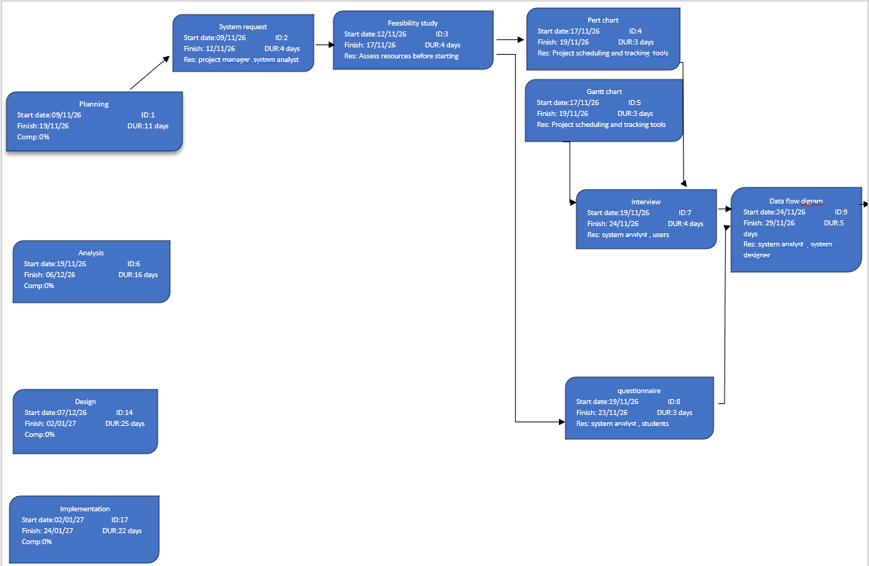

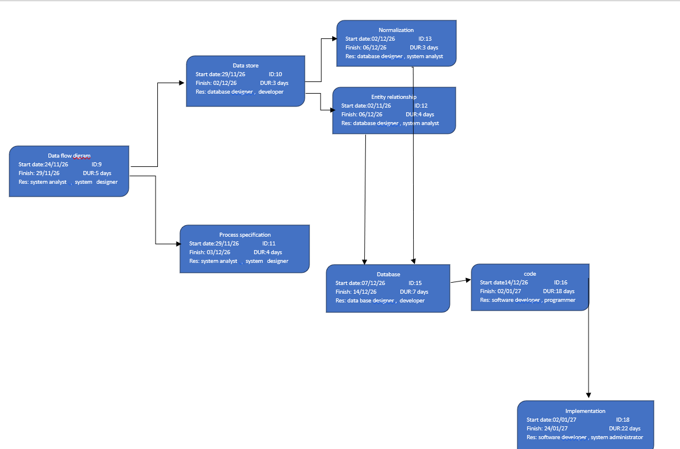

Gantt chart (MS-Project_Time Estimates)

